HW 8: ANN with Tensorflow Playground

John Robinson

05/14/2021

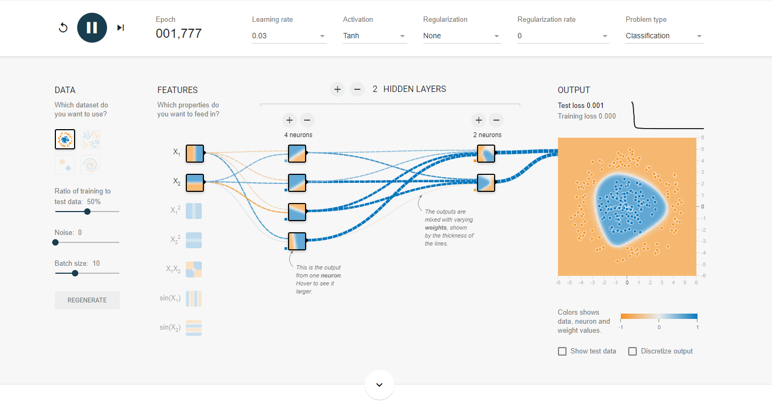

Above is just the default neural network analysis of the circle data with the Tanh activation function, it quickly separates the data.

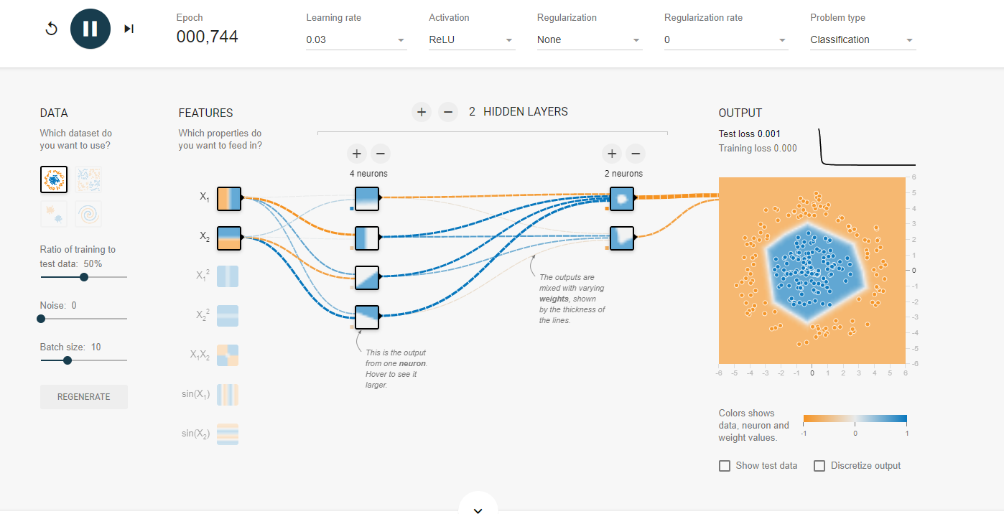

Applying the ReLU activation function to the circle dataset providing a more rigid fit for the output

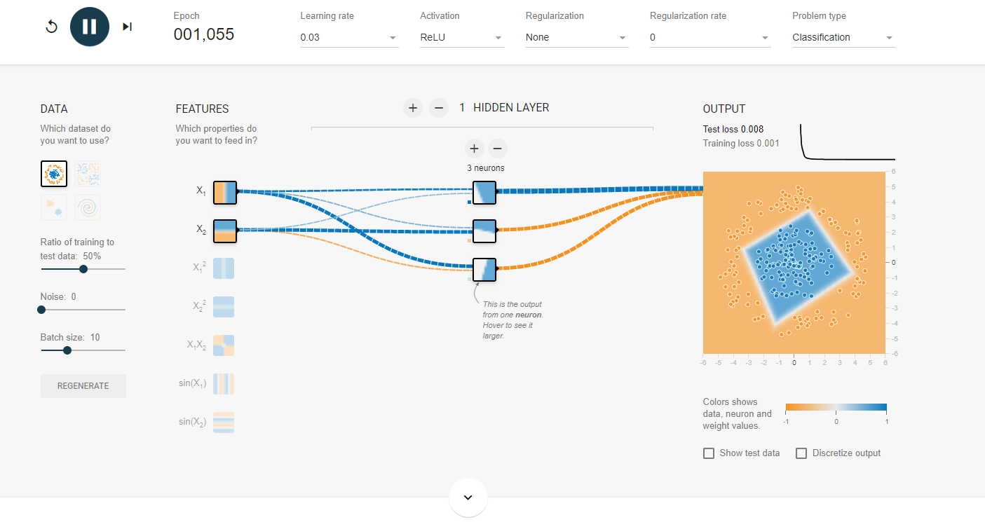

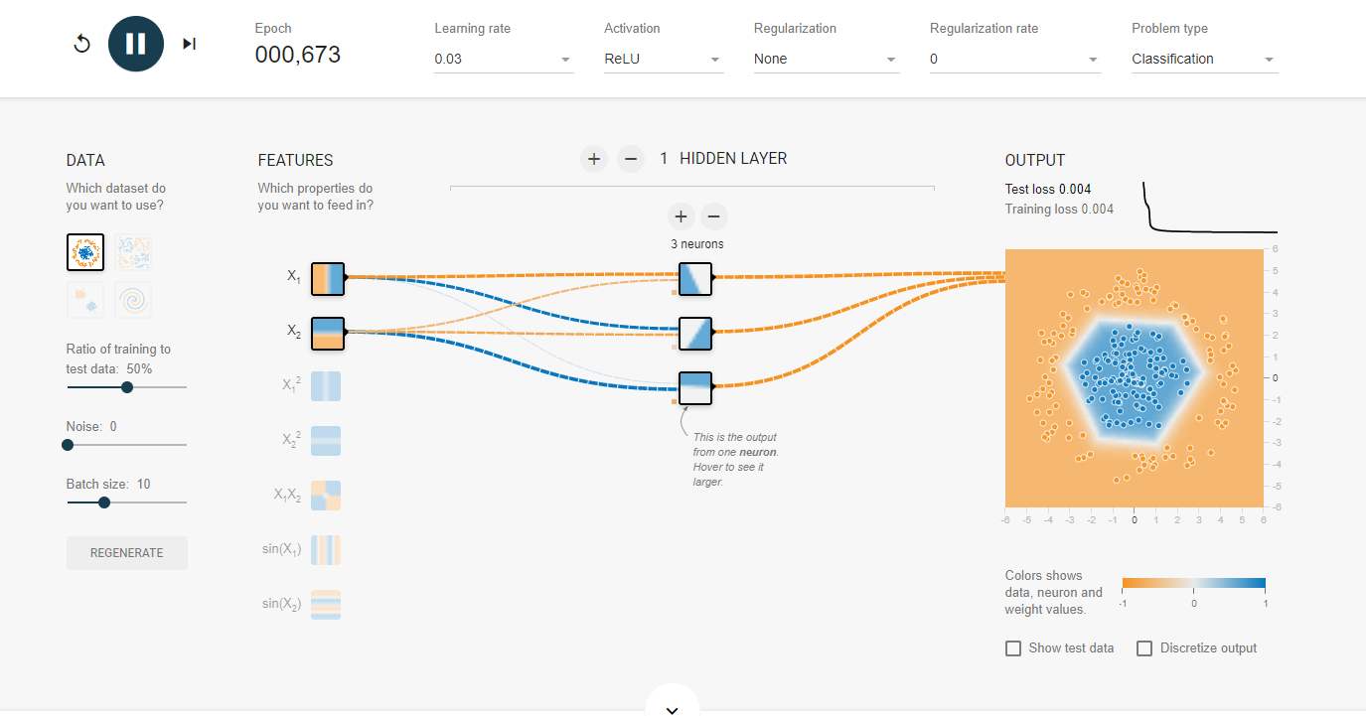

Reducing the number of hidden layers and the number of neurons in that layer lead, took a variable amount of time to complete and had different results after multiple runs.

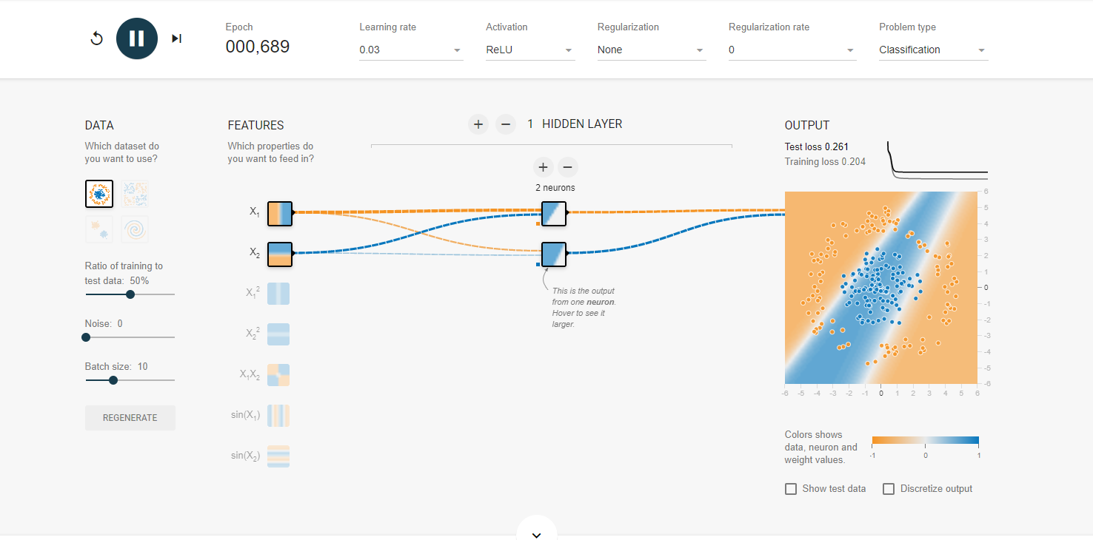

Reducing the number of neurons to an even lower number causes it to underfit the training set

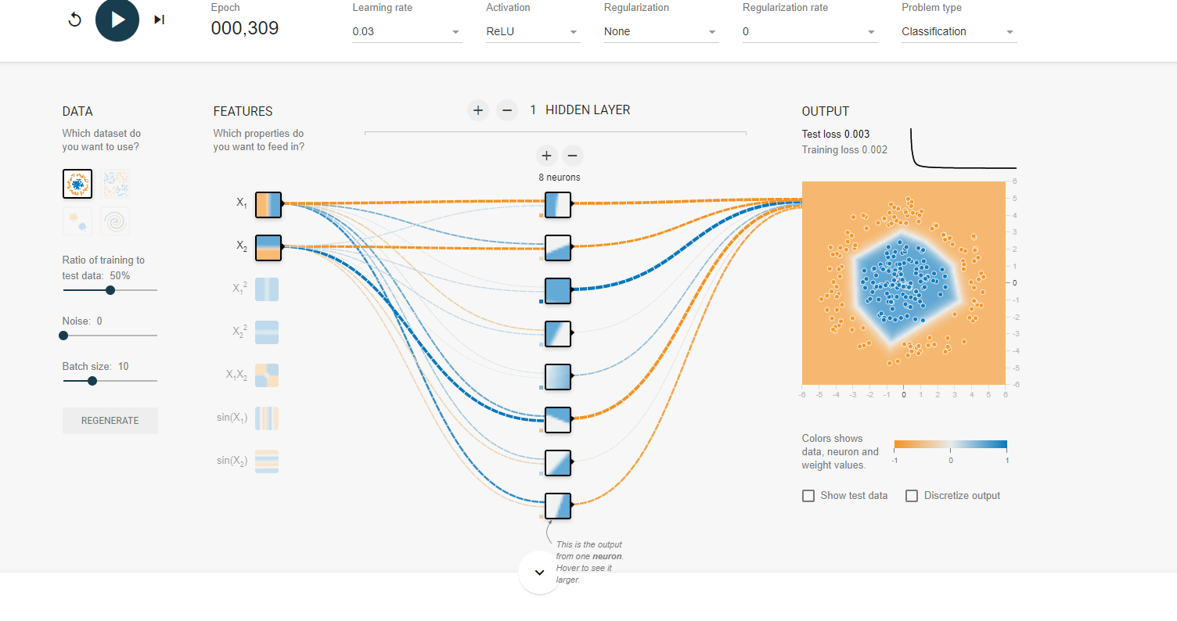

Moving number of neurons to 8 proves to an efficient number as it doesn’t get stuck even with multiple runs.

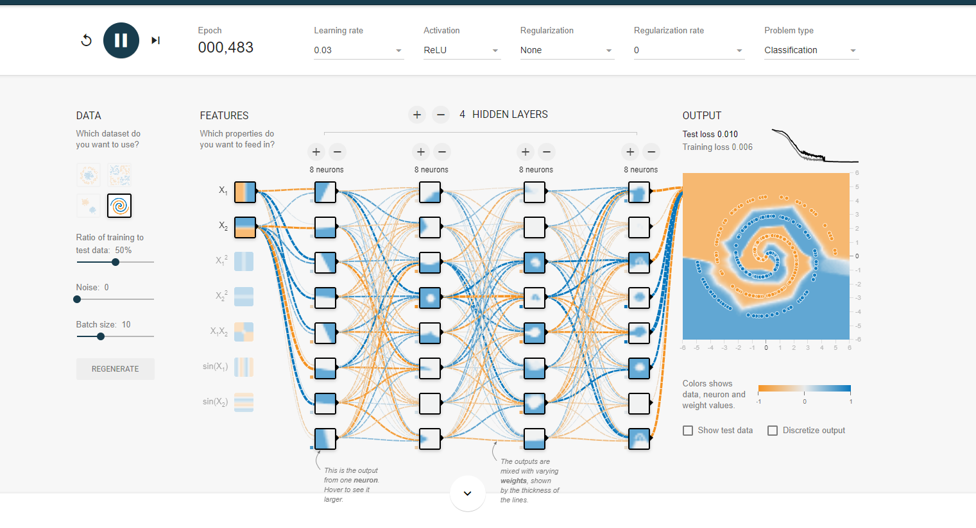

Spiral data analysis with ReLU activation function along with 4 hidden layers and 8 neurons per layer providing a decent fit for the spiral dataset.

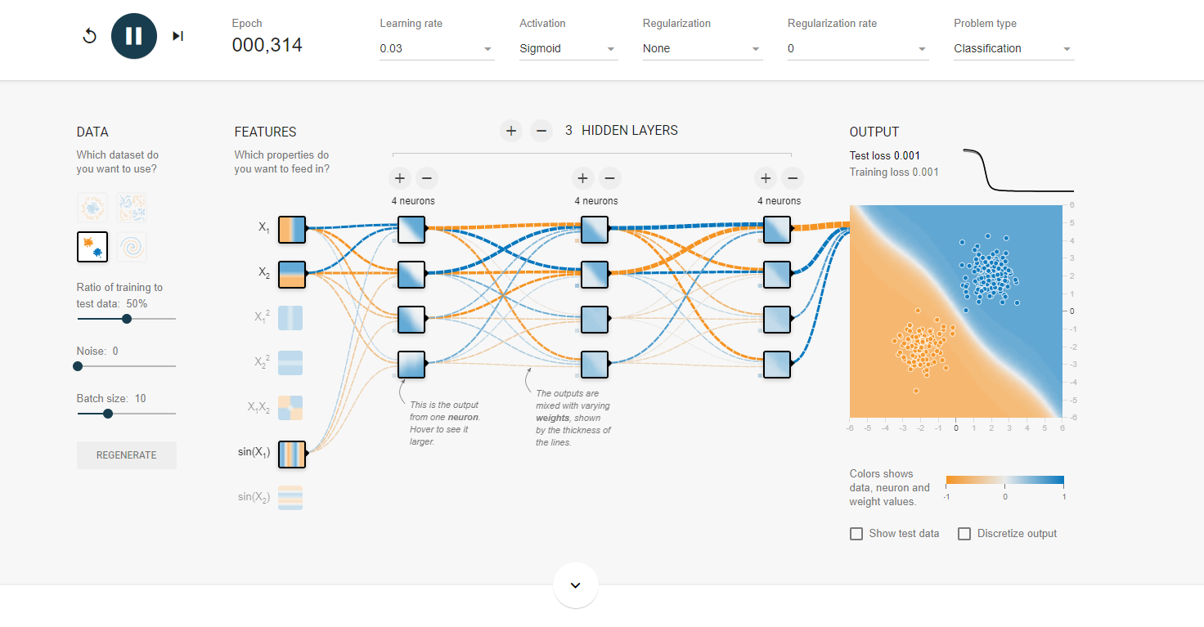

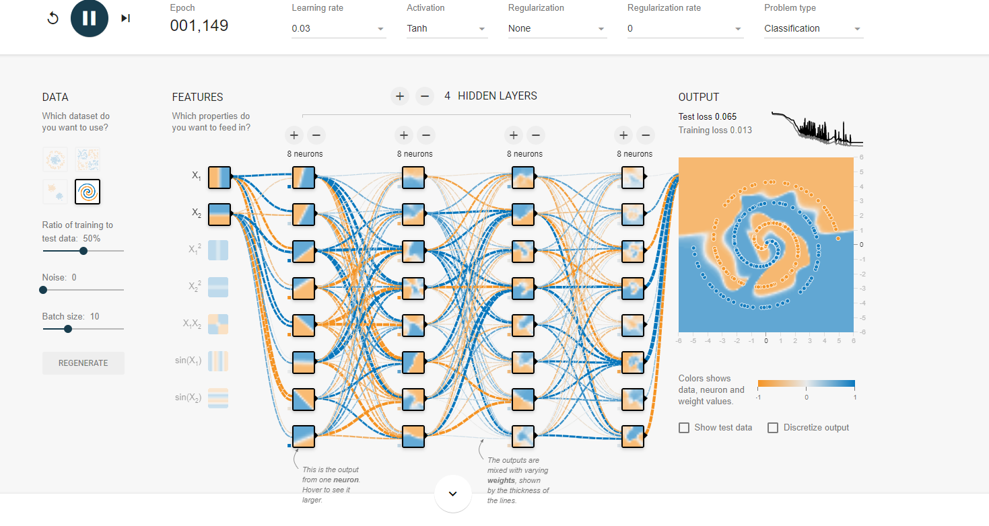

I tried changing a few parameters to varied success. I got some success using the sigmoid function but only with the Gaussian dataset. I also got a mess of matching attempting to apply Tanh activation function to the spiral dataset